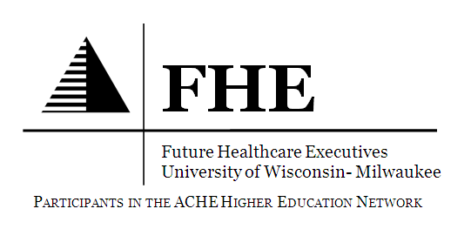
Events in April
March Newsletter

• • •
Future Healthcare Executives (FHE) is a participant in the ACHE Higher Education Network. Our local chapters, the Wisconsin Chapter of the American College of Healthcare Executives (ACHE) works directly with FHE to ensure students receive the best information and experiences to prepare us for our future in the healthcare industry. More information about the Wisconsin Chapter of ACHE can be found at: http://wisconsin.ache.org
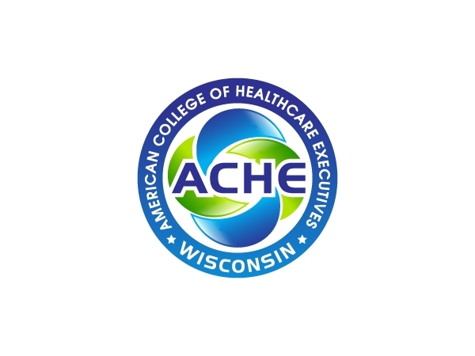
Members of FHE and new grads can keep current on the state of healthcare and get involved by joining and participating in events hosted by the Wisconsin Chapter of the American College of Healthcare Executives. Many local programs are free for registered Student Associates! Learn more about our chapter and upcoming events at http://wisconsin.ache.org and join ACHE at www.ache.org

• • •
Future Healthcare Executives (FHE) is a participant in the ACHE Higher Education Network. Our local chapters, the Wisconsin Chapter of the American College of Healthcare Executives (ACHE) works directly with FHE to ensure students receive the best information and experiences to prepare us for our future in the healthcare industry. More information about the Wisconsin Chapter of ACHE can be found at: http://wisconsin.ache.org
Members of FHE and new grads can keep current on the state of healthcare and get involved by joining and participating in events hosted by the Wisconsin Chapter of the American College of Healthcare Executives. Many local programs are free for registered Student Associates! Learn more about our chapter and upcoming events at http://wisconsin.ache.org and join ACHE at www.ache.org

April 7^{th:} FHE Guest Speakers
- Join FHE in welcoming Seth Teigen, FACHE – ACHE-WI Chapter President and Regional Vice President of Ancillary Services at SSM Health Care. We also welcome Andy Hillig, FACHE- ACHE WI Regent and Past President, and also the Vice President of Operational Excellence at Wheaton Franciscan Healthcare.
- The event starts at 6:30 PM and will be held in the UWM Student Union Room 280.
- It is open to all UWM students and guests. FREE pizza and beverages will also be provided!
- April 8th : EPIC Tour
- Come join FHE members in Verona, WI to see the exotic EPIC campus!
- The event starts at 2:30 PM and we have a carpool system set-up to leave for Verona at 12:30 PM.
- FHE members should RSVP to fhexecs@uwm.edu if interested and contact a board member regarding carpooling.
- April 21st: ACHE Leadership Development Program Early Careerist Mentor Panel
- Event is from 5:30 PM – 8:30 PM in the UWM Kenwood Interdisciplinary Research Complex (KIRC) Room 1150.
- Topics of discussion will include: graduate school advice and tips, how to land a fellowship and the purpose of fellowship opportunities, and other general career guidance from successful leaders in healthcare under the age of 40.
- It is open to all UWM students and guests.
- May 5th: FHE Guest Speaker
- We welcome you to join us in having Pam Ott- CPA, CMA, CRCR, MBA, FHFMA, FACHE- Vice President of Finance- Sheboygan/Calumet County Patient Service Area at Aurora Health Care come and speak to our students.
- May 20th: FHE Spring Social
- SAVE THE DATE! Join FHE members, guests, UWM students, and FHE speakers that have participated at our events throughout the year to wrap-up the academic year.
- Starts at 6:00PM in the UWM Student Union Wisconsin Room.

So far this past February and March
- February 18th : FHE Alumni Panel and Aurora Executive
- FHE had the pleasure of hosting this wonderful event that featured UWM Health Care Administration (HCA) alumni Shari Azinger, MSW, Nick Blish, PHR, SHRM-CP, and Sarah Donovan, MHRLR. In addition, UWM alum Gary Balcerzak, MS, VP of Operations at Aurora Health Care joined us too which gave a great perspective on the topics we discussed.
- We want to send a really big thank you to all of our panelists for providing such great insight and taking the time to meet with us!
- February 23rd : UWM College of Health Sciences (CHS) 2016 Leadership Healthcare Forum
- This event was a HUGE success for FHE as a whole and UWM’s CHS.
- A group of 10 FHE members volunteered by helping with registration, collecting and organizing question cards to ask the panel of professionals, and other miscellaneous tasks throughout the event.
- Topic of the Forum: Healthcare Wellness Innovation and Precision Medicine. Steve Burd, Founder & CEO of Burd Health and former Chairman & CEO of Safeway Inc. moderated a lively discussion on the field of precision medicine – what it is and how to accelerate innovations into every day clinical practice so everyone benefits.
- FHE members truly enjoyed learning so much from this session and meeting health care professionals. FHE hopes to continue assisting with this great event on an annual basis!
- February 25th: Geek Week 2016 at UWM: High Tech Future 2.0
- FHE members and UWM students had a few presentations and information displayed about the research they are currently conducting related to health care informatics. Students were given the opportunity to network and learn more, and get to know one another during this event.
- February 29th: Free LinkedIn Workshop at UWM
- For the second year in-a-row FHE had honored guest Wayne Breitbarth, CPA, best-selling author, speak about the techniques and tools LinkedIn has to offer for business professionals.
- Pre-event photos were taken and distributed to attendees by a professional photographer for people’s respective LinkedIn profiles.
- FHE also raffled off some of Mr. Breitbarth’s award winning books to those in attendance! Winners need to read-up, it is a great read!
- FHE would like to send a BIG thank you to Wayne Breitbarth for sharing his ideas and taking the time to come speak to us and making the event such a great success!
- March 14-17th: ACHE 2016 Congress on Healthcare Leadership
- Over spring break week, FHE received the opportunity to send seven members to this great event!
- All seven had a fantastic experience where they learned new and interesting things in healthcare through the informational sessions and networked with current health care professionals.
- Two of our very own students were our first Program Assistants at Congress who represented FHE and UWM very well!
- FHE would very much like to thank ACHE and our Wisconsin chapter for providing our students with the opportunity to attend this giant national conference through scholarships and student support! FHE would not have been able to do this without ACHE, and we cannot say thank you enough.
- March 19: Fight for Air Climb
- FHE members helped volunteer at this fundraising event hosted by the American Lung Association. Volunteers handed-out water and refreshments, cheered on participants, and helped carry out the event operations. Participants climbed the U.S. Bank skyscraper with friends, family, and co-workers to raise money to support the mission of the American Lung Association.

ACHE Events Coming Soon
- September 26-28, 2016: ACHE-WI 2016 Annual Conference
- SAVE THE DATE! ACHE-WI 2016 Annual Conference at The Osthoff Resort in Elkhart Lake, WI.
BECOMING INVOLVED
Future Healthcare Executives (FHE) is an active student organization that engages students as volunteers in the community, and provides support for students to pursue educational and professional development such as attending professional workshops and conferences. As a participant in the American College of Healthcare Executives (ACHE) higher education network, FHE has access to additional job shadowing resources and sponsors speaker events on campus featuring local healthcare executives. Joining a professional association like ACHE at the national level can help build your network and give you a head start in building your career.
- To find out more about Future Healthcare Executives (FHE) at UWM and learn how to become a member, contact fhexecs@uwm.edu. Open to all majors!
- To register as a member of FHE and receive email notices about upcoming events, google PantherSync and look for us under Future Healthcare Executives.

**Look us up on Facebook and check out our new LinkedIn group too!!**

Here are some of the pictures from the events our FHE members attended!
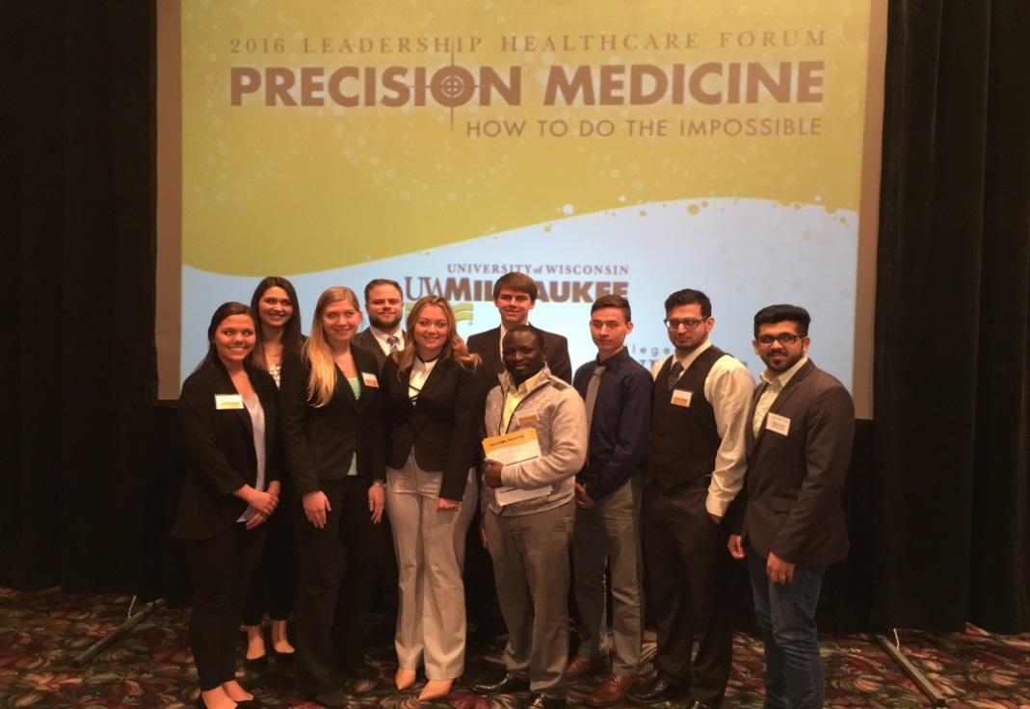
Above is a picture of FHE members at the UWM College of Health Sciences (CHS) 2016 Leadership Healthcare Forum. From left to right: Melissa Van De Hey, Brigitta Siladi, Nicole Riemenapp, Jeff Haumersen, Allison Sword, Brandon Ambrose, Morris Kromah, Aleksandar Marjanovic, Al-Mutasem Salamin, and Adam Alshehab.
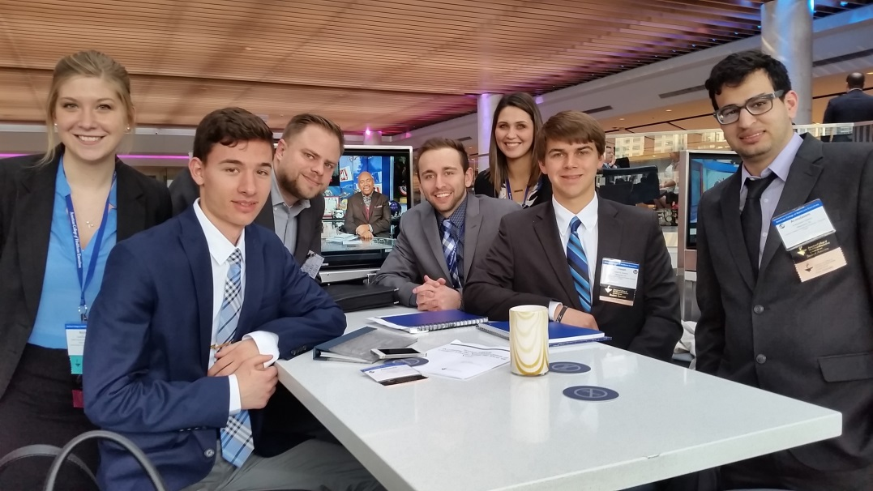
Pictured above: FHE members at the ACHE 2016 Congress on Healthcare Leadership.
From left to right: Nicole Riemenapp, Aleksandar Marjanovic, Jeff Haumersen,
Nate VandenBusch, Brigitta Siladi, Brandon Ambrose, and Al-Mutasem Salamin.

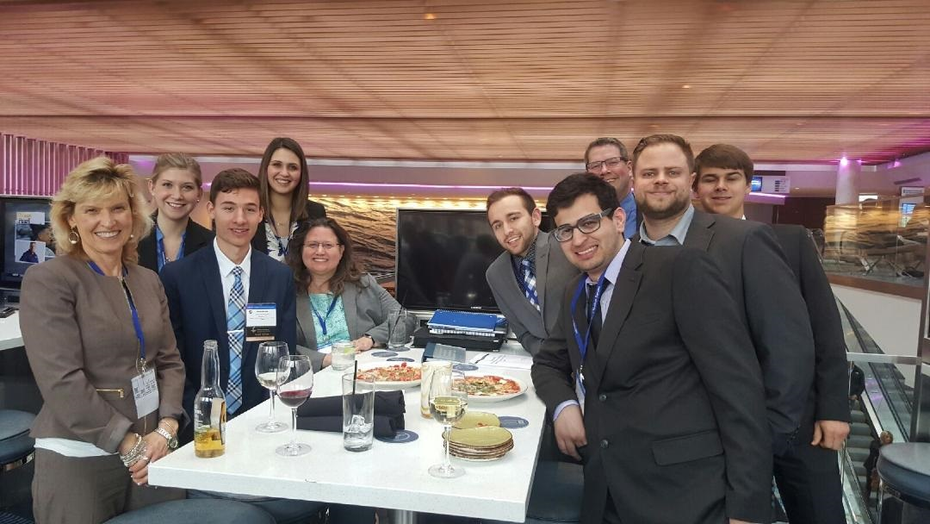
FHE members and more health care executives at the ACHE 2016 Congress on Healthcare Leadership. From left to right: ACHE Fellow Pam Ott; FHE student members Nicole Riemenapp, Aleksandar Marjanovic, Brigitta Siladi; ACHE Board member and FHE Advisor Kathleen Olewinski; FHE members Nate VandenBusch and Al-Mutasem Salamin; ACHE Board member and Fellow Tom Shorter (back row); and FHE members Jeff Haumersen and Brandon Ambrose.

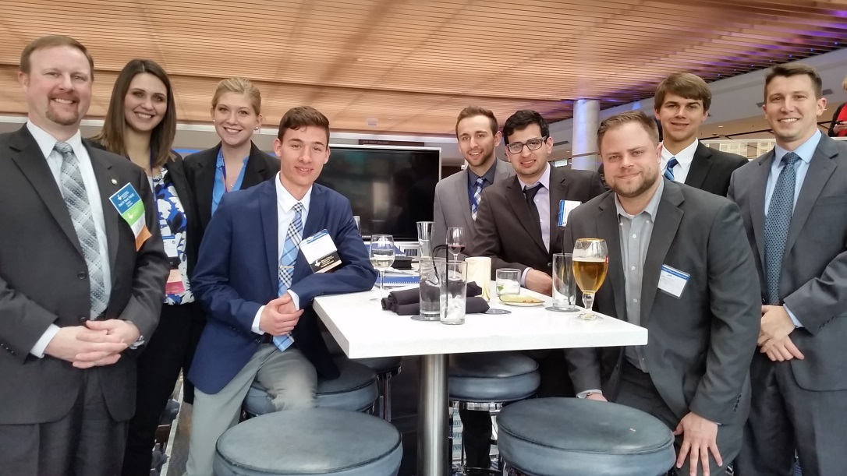
Pictured above: FHE members with health care executives “meet and greet” hosted at the ACHE 2016 Congress on Healthcare Leadership. From left to right: Outgoing ACHE Wisconsin Regent and Past ACHE WI Chapter President Brett Norell, FACHE with FHE members Brigitta Siladi, Nicole Riemenapp, Aleksandar Marjanovic, Nate VandenBusch, Al-Mutasem Salamin, Jeff Haumersen, Brandon Ambrose; and HCA alumni leader and mentor Eric Jukkala.
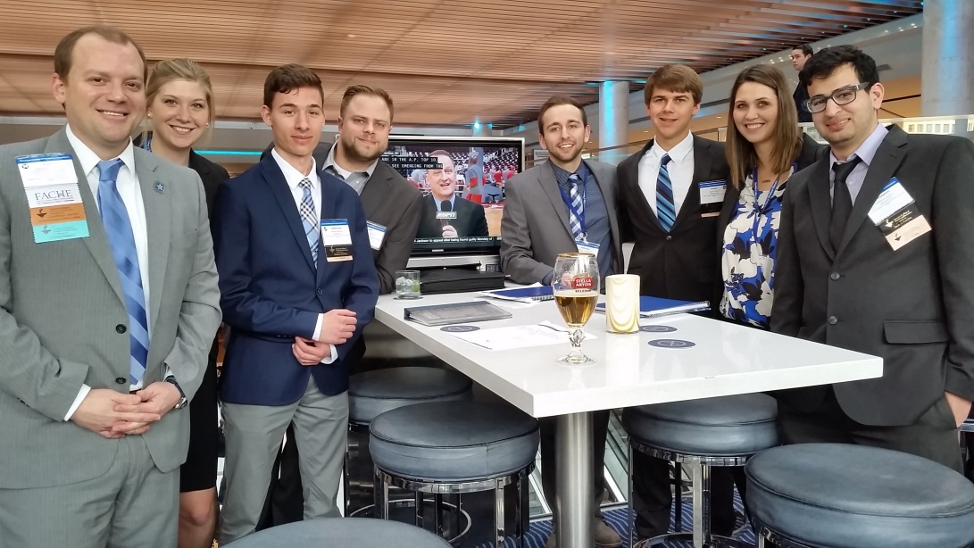
ACHE-WI Chapter President Seth Teigen with FHE student members Nicole Riemenapp, Aleksandar Marjanovic, Jeff Haumersen, Nate VandenBusch, Brandon Ambrose, Brigitta Siladi, and Al-Mutasem Salamin.

March 2016
Editor: Nate VandenBusch
Vice President, FHE

